Project Overview
This project is a personal portfolio website that showcases profile details, skills, and a contact form.
The main objective is to make the website interactive using JavaScript DOM manipulation, improve user experience, and validate form input before submission.
Goals:
- Add interactivity to static HTML elements
- Validate form inputs on the client side
- Improve UI using dynamic CSS class toggling
- Demonstrate practical usage of JavaScript events and DOM

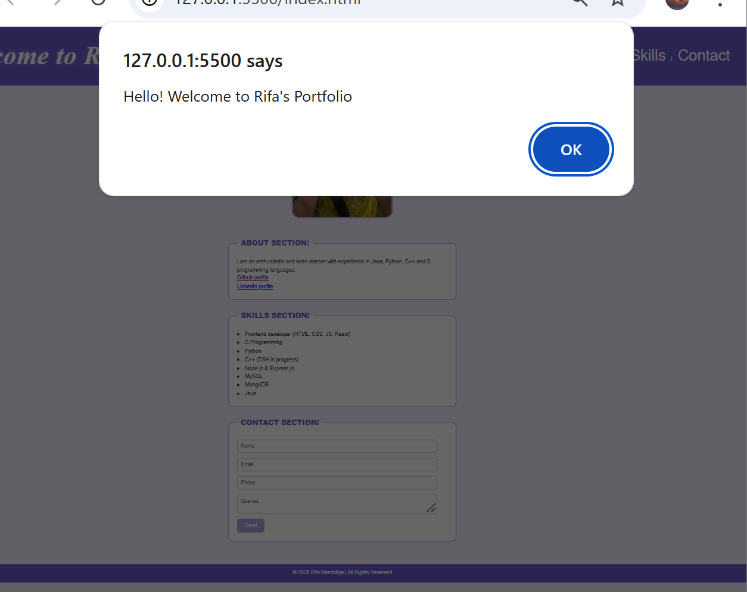

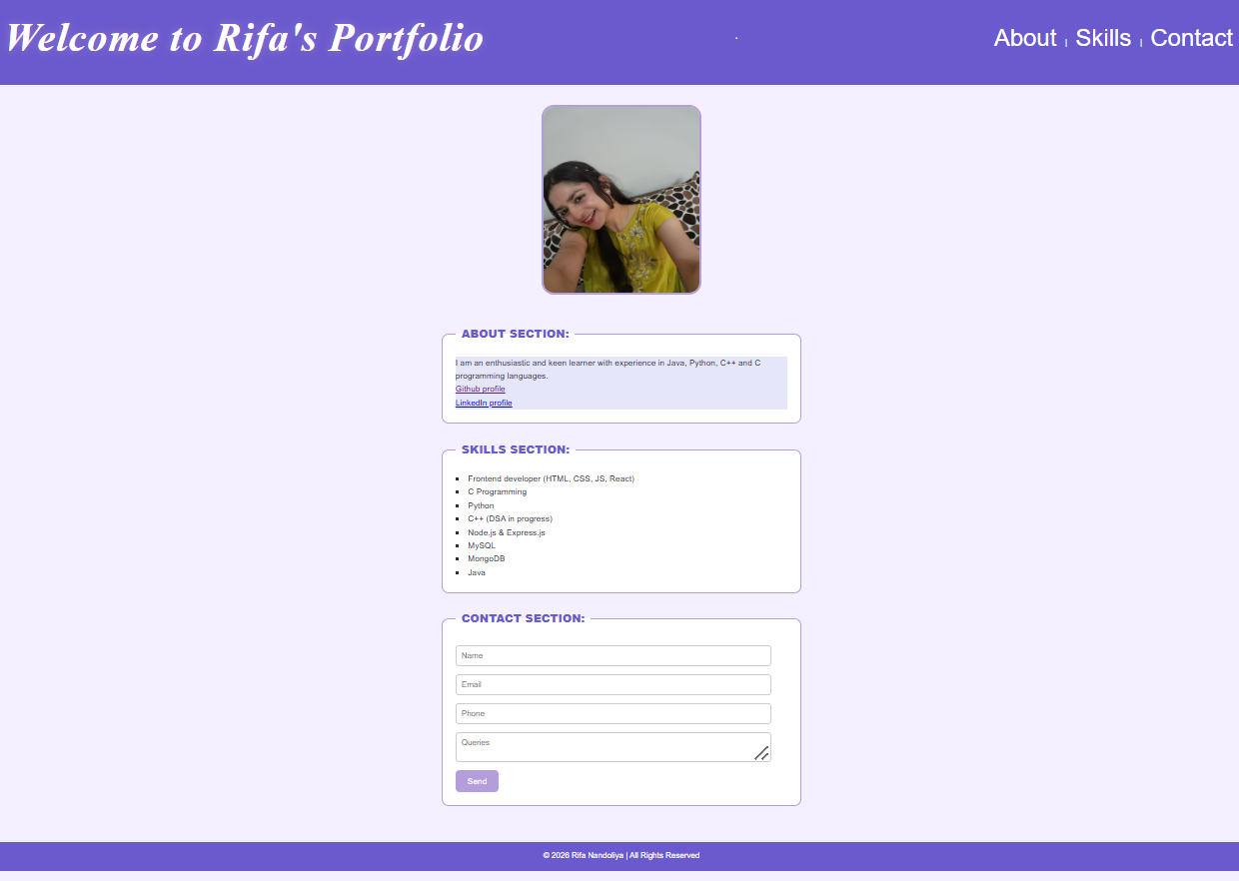

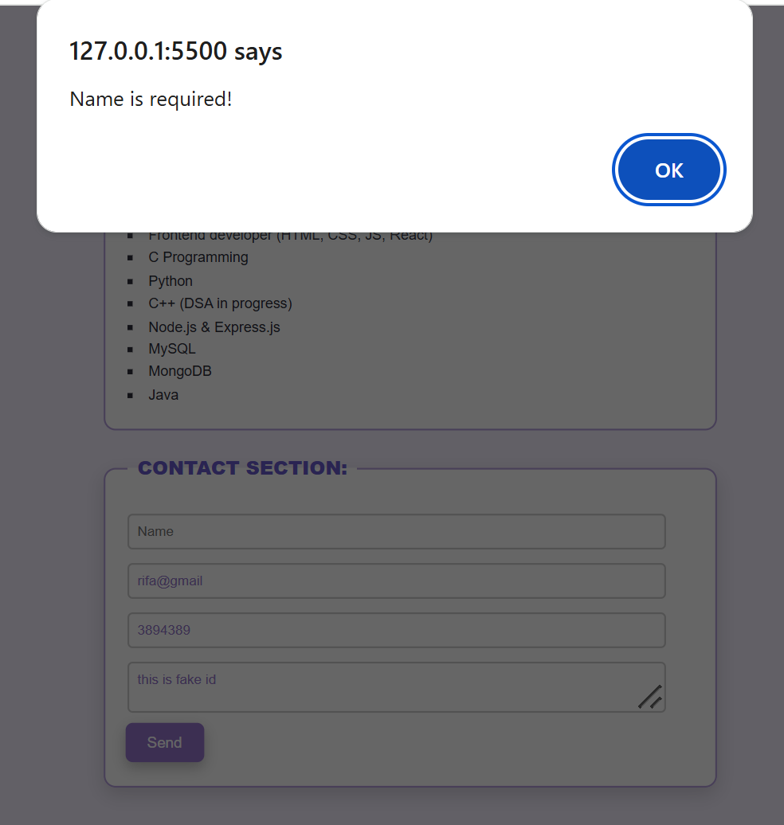

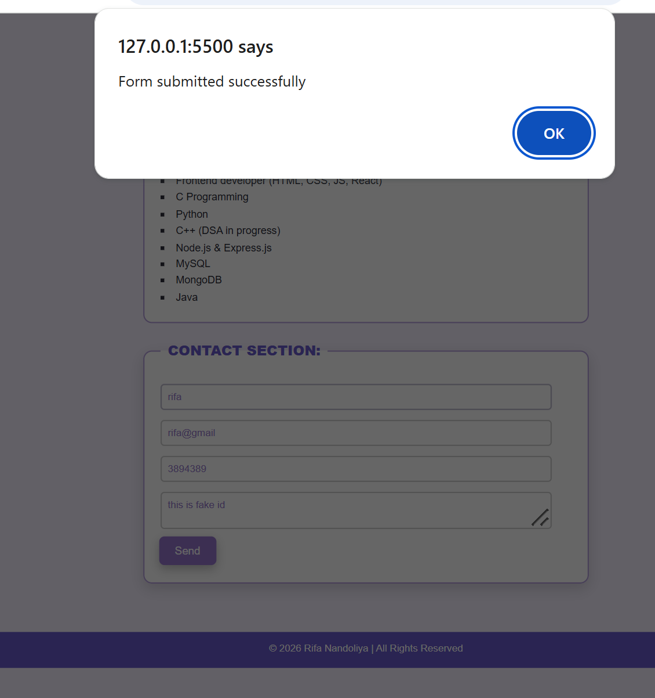
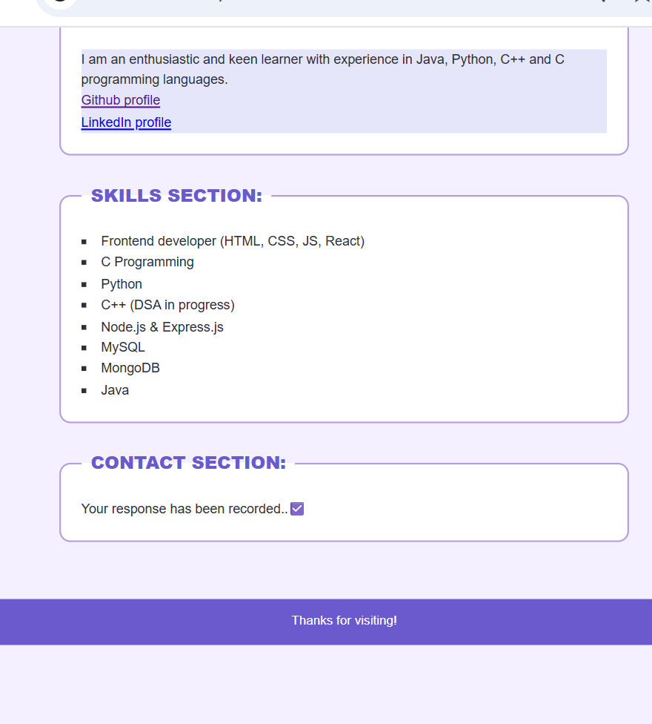

Setup Instructions
- Create three files:
- index.html
- index.css
- index.js
- Link CSS and JS in HTML:
- <link rel="stylesheet" href="index.css">
- <script src="index.js" defer></script>
- Open index.html in a browser.
No extra libraries or installations are required. Only a browser is enough.

Code Structure
project-folder
- ── index.html → Structure of the website
- ── index.css → Styling (highlight, zoomed, layout)
- ── index.js → All interactivity and validation logic
JavaScript is well organized:
- DOM loaded event
- Element selection
- Event listeners
- Utility functions
- Validation logic

JavaScript Features Implemented
1. DOMContentLoaded
document.addEventListener("DOMContentLoaded", function () { ... });
Ensures the script runs only after the HTML is fully loaded.

2. Image Hover Zoom
img.addEventListener("mouseenter", function () {
img.classList.toggle("zoomed");
});
When the user hovers over the profile image:
- zoomed class is added/removed
- Creates a zoom-in effect using CSS
Demonstrates:
- Event handling
- classList.toggle()

3. Footer Click Interaction
footer.addEventListener("click", function () {
footer.textContent = "Thanks for visiting!";
});
On click, footer text dynamically changes.
Shows:
- DOM text manipulation
- User feedback interaction

4. Navigation Highlight Toggle
navLinks[0].addEventListener("click", function (e) {
e.preventDefault();
about.classList.toggle("highlight");
});
Same logic for Skills and Contact.
Effect:
- Clicking nav links highlights sections instead of jumping
- Shows:
  - preventDefault()
  - Dynamic styling using classes
  - Clean UI behavior

Form Validation Logic
getFormValues()
function getFormValues() {
const name = nameInput.value.trim();
const email = emailInput.value.trim();
const phone = phoneInput.value.trim();
return {name,email,phone};
}
Collects and cleans user input.

validateForm()
function validateForm(){
const data = getFormValues();

if(data.name==""){
alert("Name is required!");
return false;
}

if(!data.email.includes('@')){
alert("Enter a valid email");
return false;
}

if(data.phone==""){
alert("Phone number required");
return false;
}

alert("Form submitted successfully");
form.innerHTML="Your response has been recorded..☑️";
return true;
}
Validation checks:
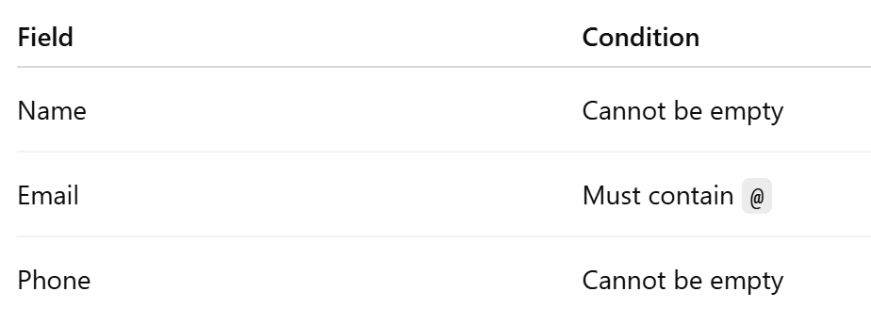
After success:
- Shows alert
- Replaces form with success message

Form Submission Handling
form.addEventListener("submit", function (e) {
e.preventDefault();
validateForm();
});
Prevents actual page reload and handles everything through JavaScript.

Interactive Elements Summary
Element | Interaction
Image | Zooms on hover
Footer | Changes text on click
Navigation | Highlights sections
Form | Validates inputs
Alert | Shows welcome message

Testing Evidence (Example Cases)
Test Case | Input | Expected Output
Empty Name | "" | Alert: Name required
Invalid Email | abc.com | Alert: Enter valid email
Empty Phone | "" | Alert: Phone required
All Valid | Correct inputs | Success message displayed

Technical Details
- Language: JavaScript
- Concepts Used:
  - DOM Manipulation
  - Event Listeners
  - Conditional Statements
  - Functions
  - Form Validation
  - CSS Class Toggling
No external frameworks used. Fully vanilla JS.

